**At what value (%) does doing the research first become better than not doing the research?**

At % = 41% doing research first become better than not doing the research.

Where does it again become worse than not doing the research?

AT % = 58% doing research has become worse than not doing the research.

Red line shows research and the blue line show the no research EV values.

**How do you explain the usefulness of the information in this sensitivity analysis?**

To get the optimum strategy, we need to calculating the X% values as we did in the problem set 9 and 10 in the module 4 of this course, like finding the probabilities and using those probabilities to draw a tree. And finding Excepted Values at each node and evaluating the optimum strategy. This analysis only provides information at one point. But this Sensitivity analysis will provide a total graph of X% at each percent and making things easy to visualize and understand at what point research is required and not. And this also says until what percent doing research is better and at what point we need to stop investing on the research work. This is the most important usefulness of this sensitivity analysis.

**Use R and Rattle to Perform Bottom-up Tree Model Diagnostics:**

Execute a tree model with the defaults. To know that you loaded everything right, you should see a Root node error of 74/140 = 0.52857.

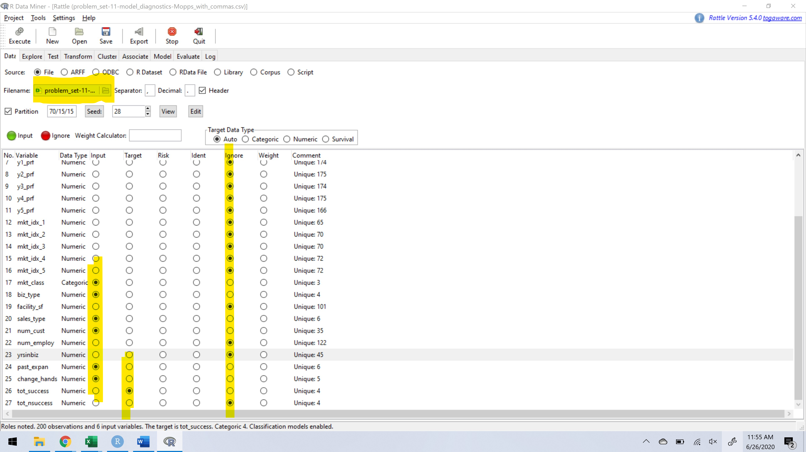

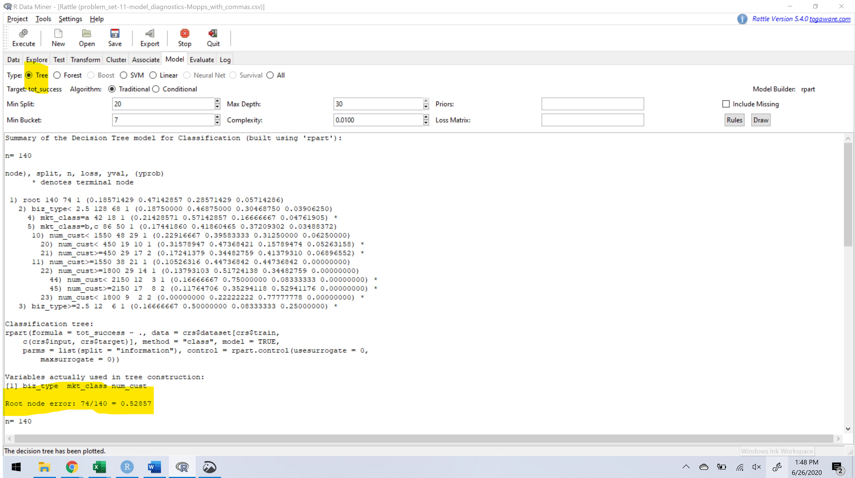

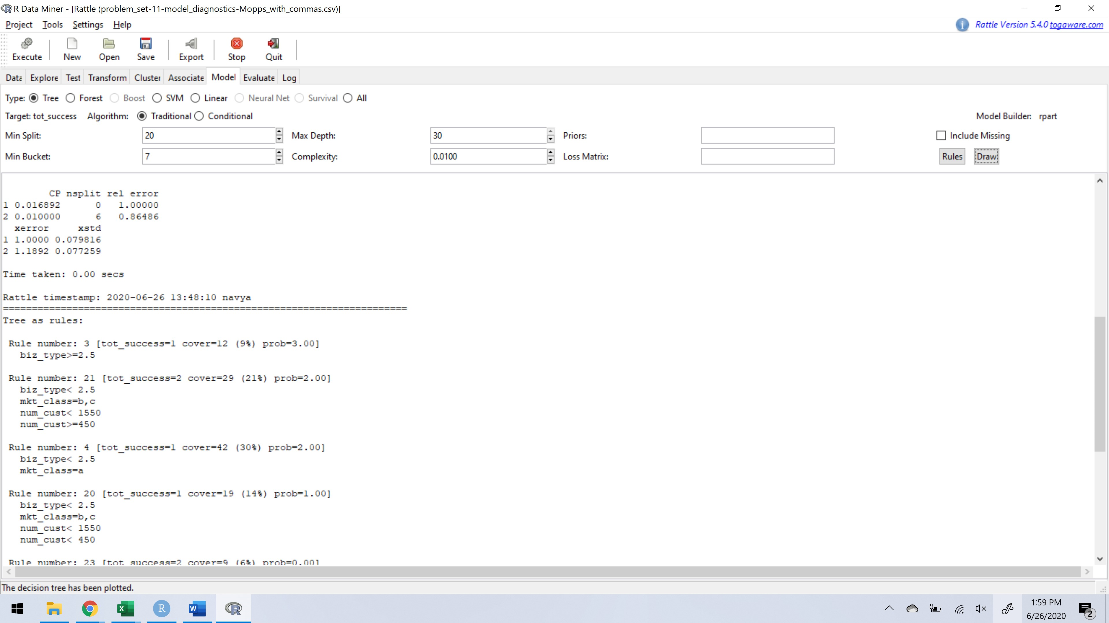

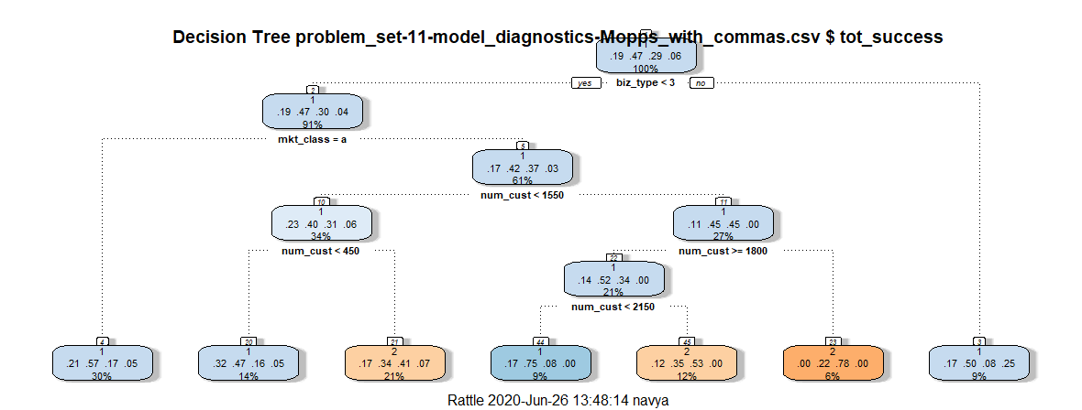

Max. Depth: Maximum number of levels of splitting.

Min. Split: This is minimum number of observations that exist in a node resulting from a split before a split will be performed by default its value is 20.

Min. Bucket: Minimum number of observations allowed in any leaf node and default value is equal to one third of min. split.

Complexity: Minimum improvements in the model that is needed at each node.

**After changing the min. bucket from 7 to 1, complexity from 0.01 to 0 and seed = 28.**

**This combination of tuning parameter the “xerror” value is 0.25676. this the lowest overall cross validation error.**

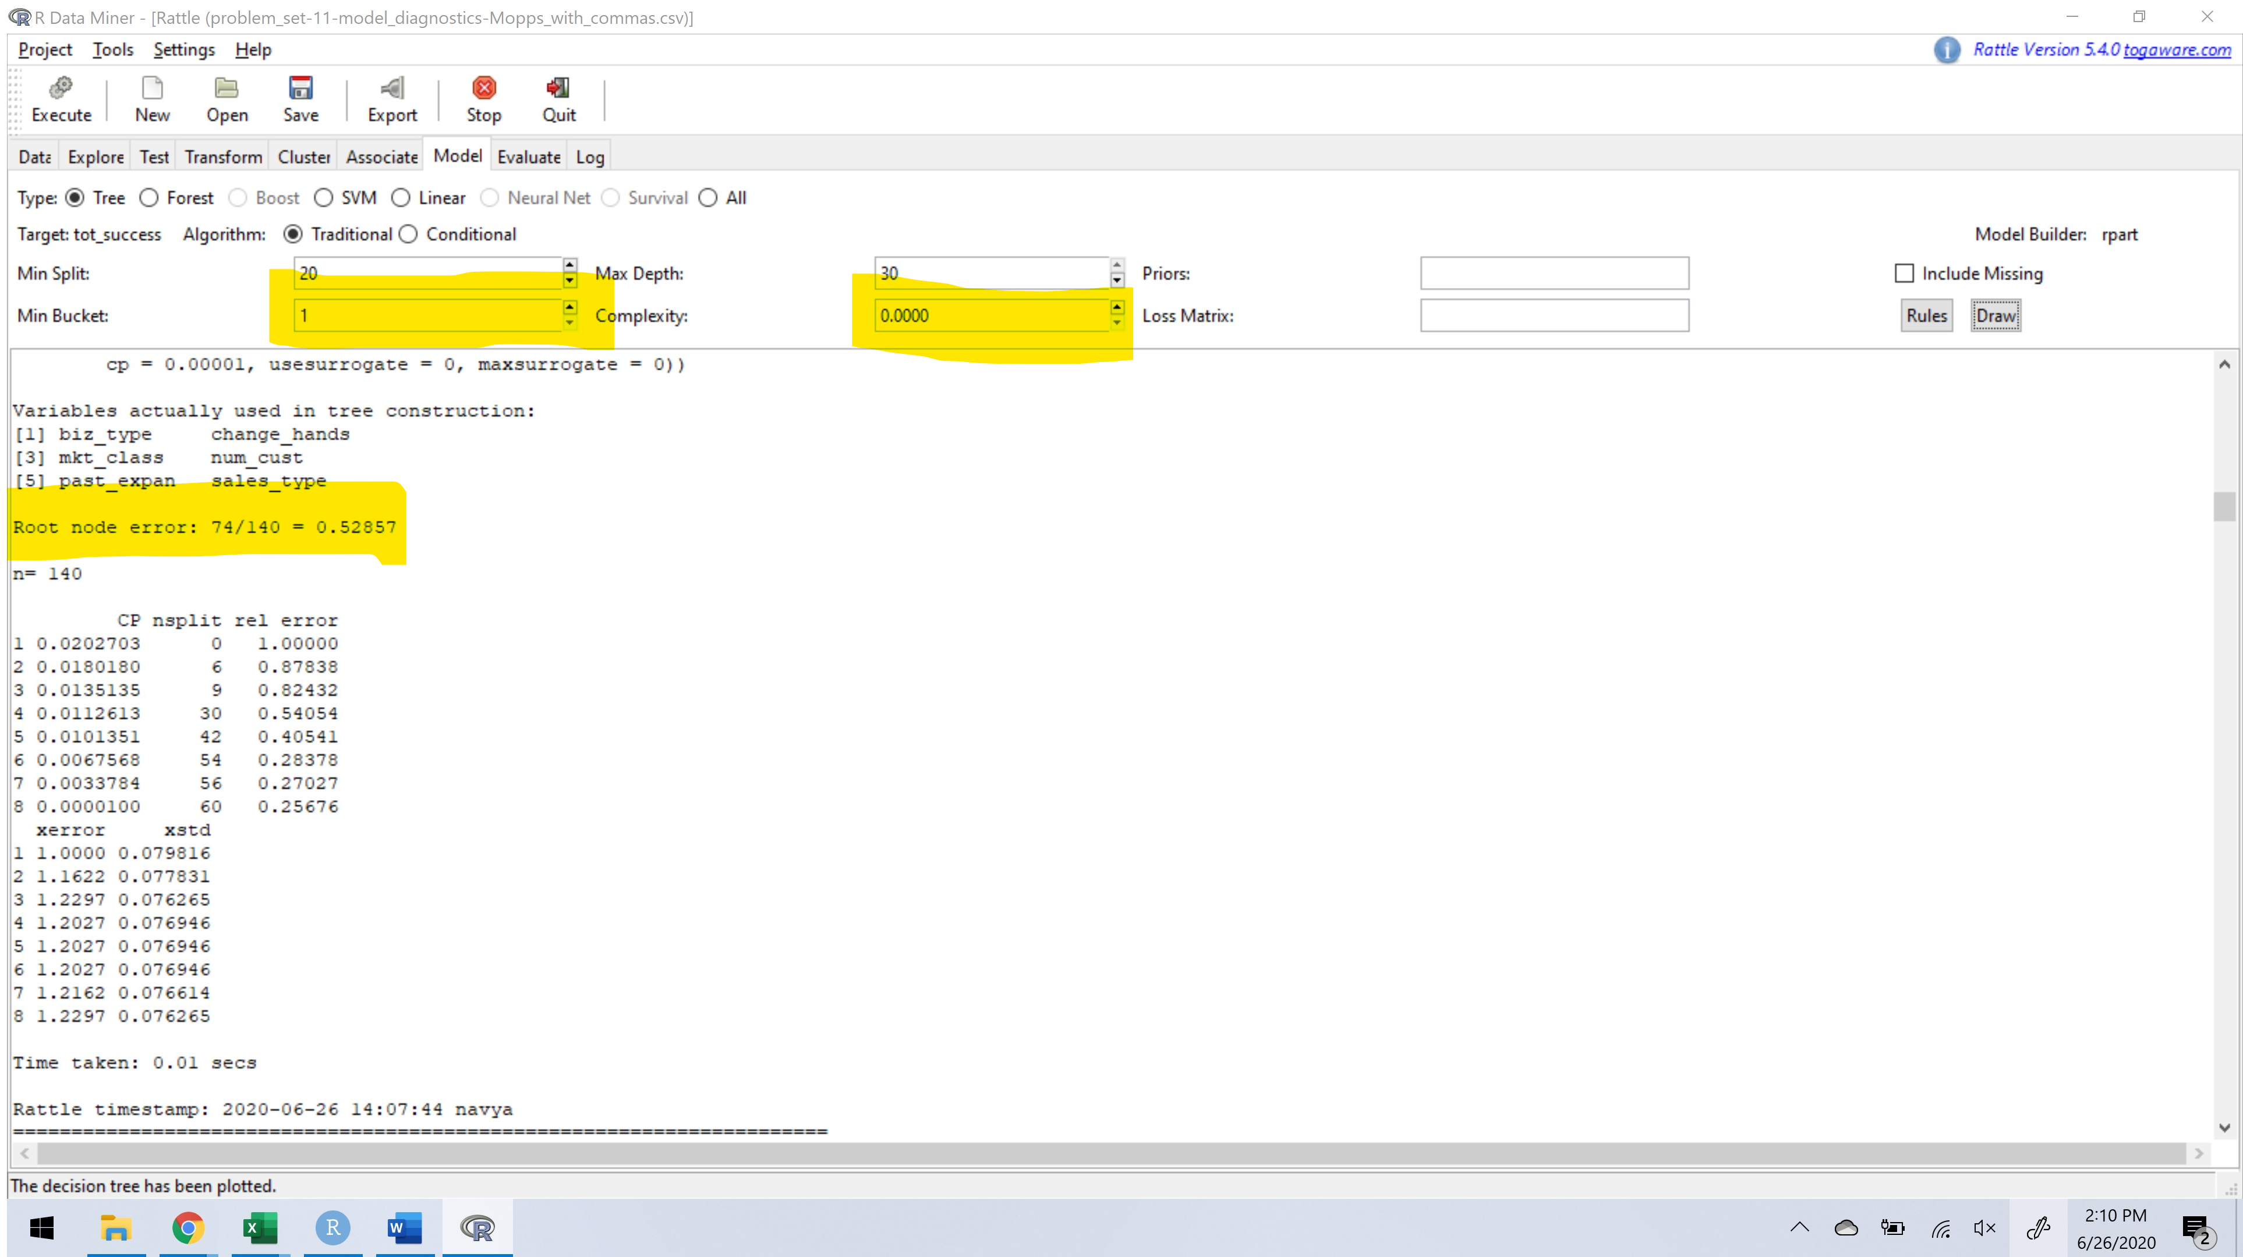

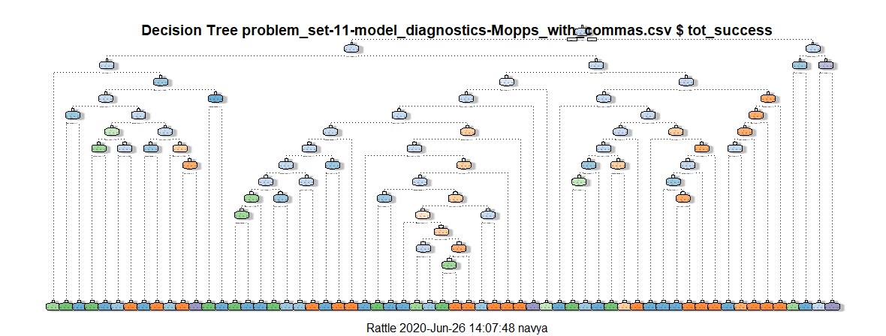

**To simplify this tree above, I have changed few tuning parameters and the complexity.**

**After changing the min. bucket = 7, complexity value from 0.01 to 0.025 and changed seed value from 28 to 42.**

